

**Swarm Robotics**

**College of Engineering and Computing**

**Department of Electrical and Computer Engineering**

**ECE 449**

**Senior Design Project**

**Dr. Jamieson & Dr. Van Scoy, Advisors**

**Ryan Campbell, Rob Lytton, Ben Eicher, Mika Burmester**

**May 10th, 2024**

## 

**1 Introduction 2**

**2 Project Background 2**

2.1 Previous Work 2

2.2 Boids (program) 7

**3 Project Research and Solution Process 8**

3.1 First Robot Design 8

3.2 Second Robot Design 10

3.3 Third Robot Design 11

3.4 Improving the Chassis 12

3.5 Pose Detection using Computer Vision 15

3.6 Implementing Boids using Pose Detection 26

**4 Final Results 28**

**5 Future Work 28**

**6 Engineering Standards and Practices 29**

**7 Conclusions 30**

## 

## 1 Introduction

In nature, there exists a phenomenon called swarm behavior in which individual entities move together in a group. This behavior is observed all over the animal kingdom and is commonly exhibited by species of insects, fish, and birds. Swarm behavior is a form of emergent behavior that's complexity is the result of simple interactions happening at a small scale. Swarms exhibit two interesting properties: they can recover from the failure of one entity, and they can easily scale to accommodate new entities.[1]

Swarm robotics tries to recreate swarm behavior using robots.[2] It has grown in popularity because it presents a way to develop a coordinated fleet of robots that can scale and recover from individual failures. This technology has applications such as the traversal and mapping of large or dangerous areas quickly. An example of a situation where this may apply is search and rescue which often requires large areas to be searched in a short period of time – exactly what this technology excels at. Mapping disasters is another application, since hazardous conditions prevent people from entering an area to gather information. Some search and rescue events in which swarm robots may be useful include avalanches, nuclear disasters, man overboard (MOB) accidents, and building fires.

The goal of our project is to create a group of four robot agents that exhibit swarm behavior. In the following sections, we will first discuss the background necessary to understand the project, present our research, solution, results, and plans for future work.

## 2 Project Background

### 2.1 Previous Work

In 2021, the swarm robotics project started at Miami. The goal for this project was to create a foundation for swarm robotics that could be built upon by future researchers at Miami. By the end of the project, the group built two robots that could move in accordance with instructions sent to them wirelessly by a master computer connected to an overhead camera. Figure 1 shows a high level diagram of the system. The robots were built using a 3d printed chassis, 2 continuous servo motors, a ball bearing wheel, and a BeagleBone Blue (a single board computer designed for small scale robotics projects). It includes built-in ports for motor control, GPIO, I2C, and more.[3] To power the system, a 3.3V lithium polymer (LiPo) battery was used. An AprilTag (similar to a QR code) was placed on top of the robots so the overhead camera could detect the position of the robots. The design for the robot is shown in Figure 2. An Ausdom B012CK43W6 was used for the overhead camera, and it was connected to a Raspberry PI B3+ which ran image processing and control code on it. A UDP connection was used to communicate movement instructions from the Raspberry PI to the BeagleBones. Figure 3 shows the view from the overhead camera in action. Figure 4 shows the fully assembled system. Figure 5 shows a long exposure photo of the system running.

There is little to no documentation detailing on how to use the project’s code.[4] As a result, future groups created their own codebases from scratch.

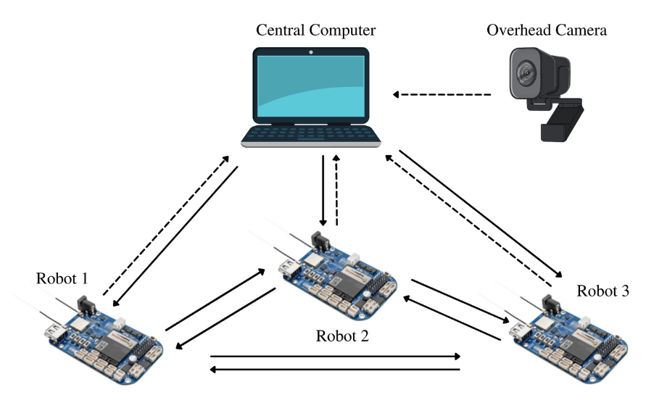

**Figure 1** High level diagram of the system.

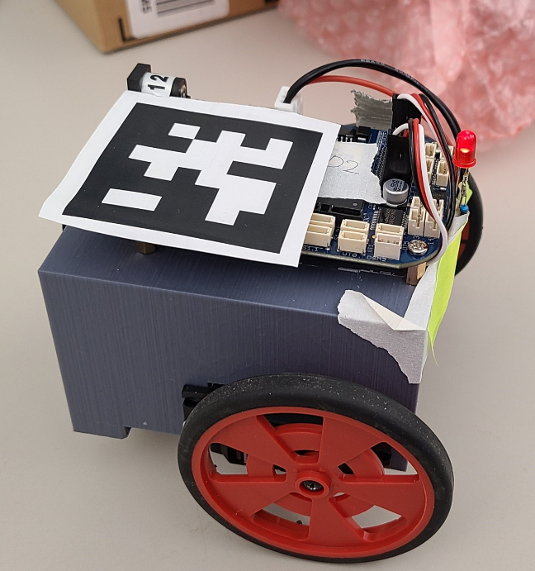

**Figure 2** One of the two robots built by the 2021-2022 team. The design consists of a 3d printed chassis, two continuous servos, a ball bearing (hidden), a BeagleBone Blue, and an AprilTag.

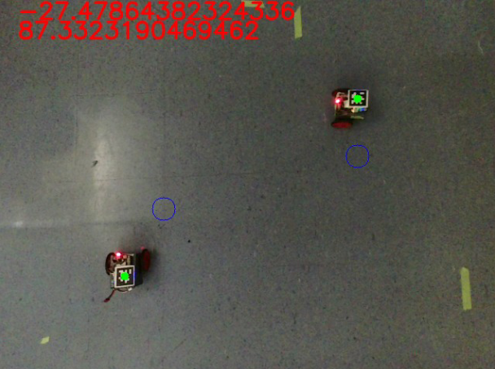

**Figure 3** The view from the overhead camera. The green dots represent detected robot positions, and the blue circles show the robots’ target positions.

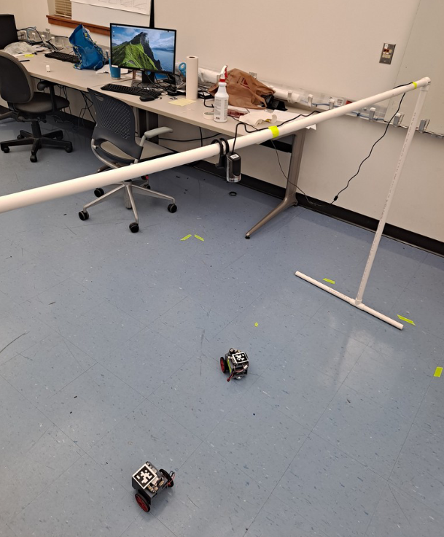

**Figure 4** The complete system created by the 2021-2022 team.

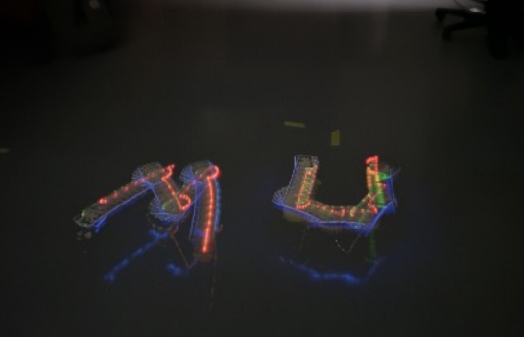

**Figure 5** Long exposure image of the robots drawing the letters ‘MU’.

During the summer 2022 term, a student worked on integrating a HC-SR04 ultrasonic sensor and a GP2Y0A21 infrared distance sensor into the robot. After that, they characterized the sensors’ output readings at different ranges and developed mathematical models to predict the distribution of readings. All code from the summer 2022 work was written from scratch.[5]

Another senior design team did work on this project during 2022-2023. They made the system less centralized. To do this, they gave two robots specialized roles. One robot was outfitted with a Logitech C270 camera connected to a Raspberry PI B3+ running code that could detect the position of colored squares in an image. The Raspberry PI sent the result of the square detection system to a BeagleBone Blue via a serial connection which was used to control the robot’s movement. Mounted on the other robot were colored squares; by doing this, the robot with the camera could detect the other robot’s position. To accommodate the colored squares and Raspberry PI, the group redesigned the chassis. The robot with the camera was called the “chaser” because it was programmed to chase the other robot using data from the camera. The chased robot was called the “runner”. A projector displayed a color on the floor to control the robot’s state. For example, projecting a blue color would calibrate the robots, and projecting a green would activate the runner and chaser routine. Figure 6 and Figure 7 show frames from IMG_1220.MOV which depict the chaser catching the runner.

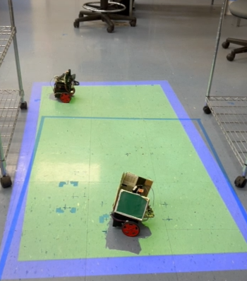

**Figure 6** Video from 2022-2023 group showing chaser (back) searching for runner (front).

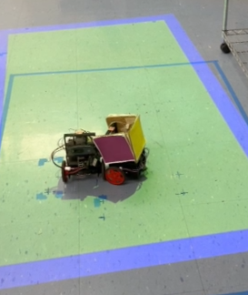

**Figure 7** Video from 2022-2023 group showing chaser (left) colliding with runner (right).

In the summer of 2023, a student developed a routine to automatically characterize a distance sensor. To test the routine, they used a SHARP 0A41SK IR distance sensor. The results of the characterization system were used to create a model for the IR sensor similar to what the student from the previous summer did.[6]

### 2.2 Boids (program)

For our project, we built upon the work from previous groups to recreate the behavior in Boids using the robot agents. Boids, a program created in 1986 by Craig Reynolds, provides a mathematical model for simulating swarm behavior of bird-oid objects called boids. Each boid moves based on three simple rules: separation, cohesion, and alignment.[7] The first of these rules, separation, instructs boids to move away from other boids that are too close. This prevents collisions. The next rule, cohesion, causes boids to head towards the average position of its neighbors. This brings boids together which has the effect of creating groups. Finally, the alignment rule steers boids in the direction their neighbors are facing. This gives the group a collective direction of travel. These rules together determine the force vector for the boid.

Figure 8 shows representations of the rules of separation, cohesion, and alignment in Boids. The green triangle represents the boid whose velocity is being calculated. The blue triangles represent other boids. The blue boids within the gray circle are considered neighbors and have an influence on the movement of the green boid. The red arrow shows the calculated force vector based on the three rules. In the first image, separation is shown by the green boid steering away from its neighboring blue boids. In the second, cohesion is shown by the green boid steering towards the average position of its neighbors. Finally, the third box shows alignment when the boid is accelerating to match the direction of its neighbors.

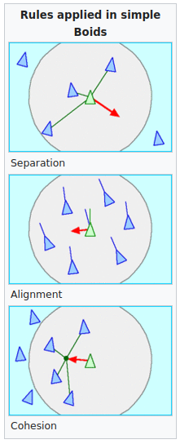

**Figure 8** Illustrations of (from left to right) separation, cohesion, and alignment in Boids.[8]

## 3 Project Research and Solution Process

As described in the introduction, the goal of our project is to create a system of four robots that move according to the movement model used in Boids. Using the previous robots as a starting point for our design, we designed and built four new robots. In the following subsections, we will discuss our research and the solutions we developed.

### 3.1 First Robot Design

Our first robot design consists of nine parts attached to a custom 3D printed chassis (detailed in *3.4 Improving the chassis*). This chassis is driven by two DC motors with Hall sensors attached to each motor to measure the motor speeds. We were unable to source more of the continuous servos and wheels used by previous groups, so we had to switch to motors and Hall sensors. Figure 9 shows a side by side of the new and old components.

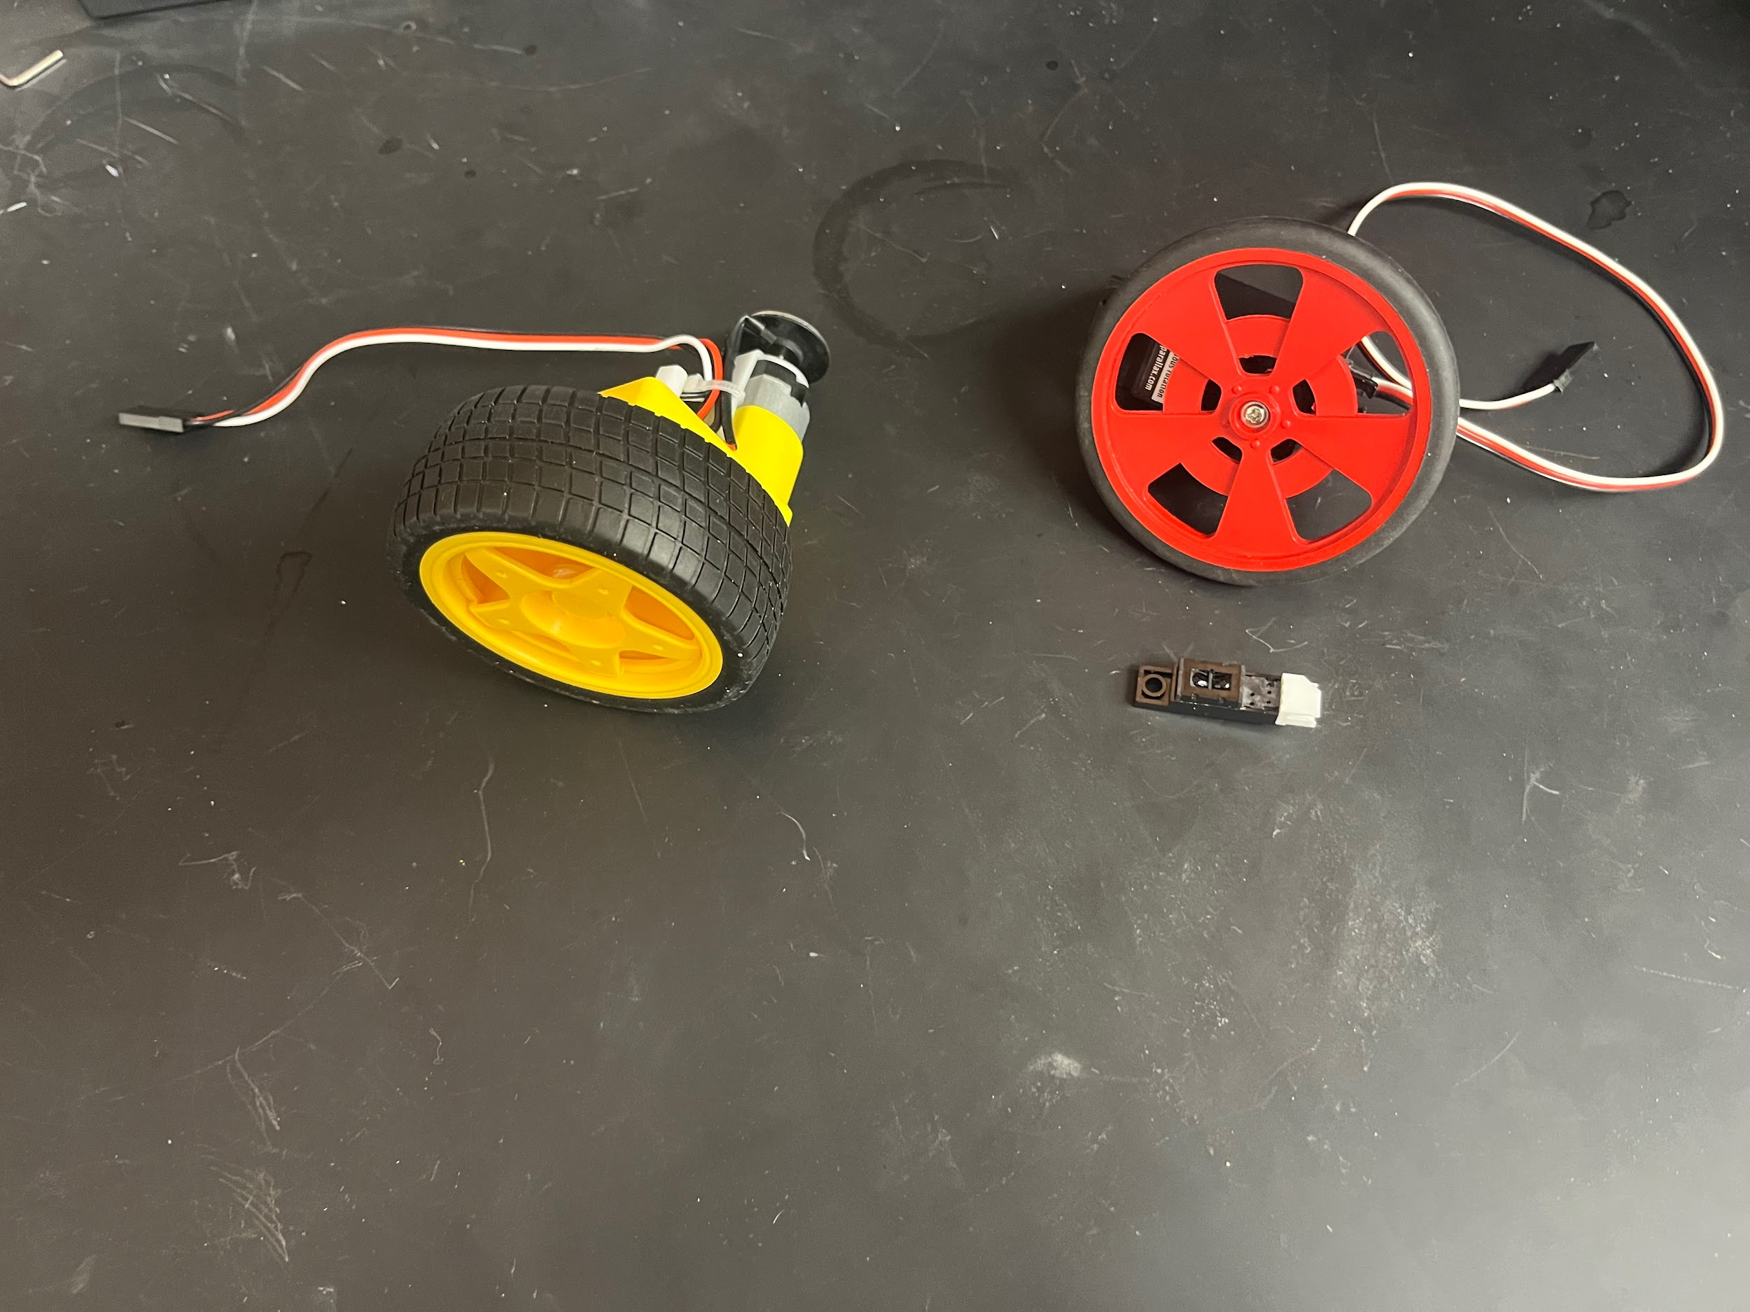

**Figure 9** New motor with Hall encoder (left) vs previous hardware (right)

A ball bearing wheel is attached to the rear of the robot to allow for easy turning. Due to its simplicity and availability, the ball bearing is kept from the previous projects instead of switching to a caster wheel or additional motors. A BeagleBone Blue – a Linux based microcontroller for robotics – is used to control the motors and encoders. A Raspberry Pi – a compact single chip computer running a custom OS – sits on top of the robot alongside a camera. The camera is connected to the Raspberry Pi, and the Raspberry Pi is connected to the BeagleBone Blue. The Raspberry Pi uses visual input from the camera to detect other robots’ poses and decide where to move. From here, the Raspberry Pi sends the calculated motor speeds to the BeagleBone Blue. The BeagleBone Blue drives the motors while accounting for the motor speed measured to ensure accurate movement. To power the system, a 7.4V 2000mAh LiPo battery is placed on the middle layer. Figure 10 shows a labeled image of the first robot design.

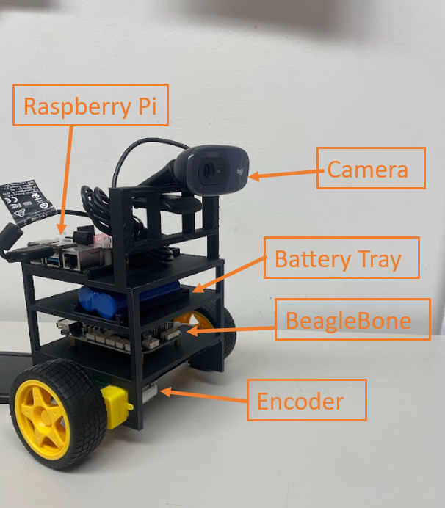

**Figure 10** The first robot design.

Due to our limited experience, we had difficulty developing code on the BeagleBone Blue. Interfacing new motors and encoders with the BeagleBone Blue proved to be a challenge. After trying two different control libraries – one native to the BeagleBone – and attempting to interact with low level files, we were unable to reliably control the motors. Additionally, we had difficulty interfacing the Hall sensors with the BeagleBone since the board is meant for quadrature encoders (eQEP), which have a total of four wires, the extra one being for direction, and our encoders typically required a PRU connection. The datasheet for the microprocessor on the BBBL did however state that the eQEP modules can be configured to use a Hall sensor by writing 2 bits to a register. We tried this, but it did not work as it appeared to only have 1 bit dedicated to the mode of the eQEP. We experienced other issues with the board including random failures, bent pins, and burnt out ports.

### 3.2 Second Robot Design

Because of the issues encountered with the BeagleBone, we changed some hardware. Since the BeagleBone only controls the motors, we replaced it with an Arduino Uno and an H-Bridge. The new Arduino still receives the motor speeds from the Raspberry Pi. We found the connection between the Arduino and the Pi introduces about a one second delay when sending motor speeds. The delay proved to be too slow as the motors moved fast enough that a crash would be inevitable within a second long sensing delay. The Hall sensors lacked a proper fixture for holding the component needed to detect rotation; instead, zip-ties were provided in the packaging. It was easy for the sensor to be knocked out of place which made them highly unreliable.

For this design, we estimate the camera, Raspberry Pi, Arduino, and motors require a current of 5A when moving. At this current, the 2000mAh battery pack can supply power for 24 minutes before recharging is required. This was deemed ineffective due to the difficulty of prototyping with such limited battery usage and the eventual power loss during the presentation of these robots.

### 3.3 Third Robot Design

Our third robot design improves the previous design by removing the Arduino Uno and using the Raspberry Pi to control the motors directly. This change reduces the system’s power requirements and simplifies the hardware. The Pi’s general purpose input / output (GPIO) pins control the motors and read the speed sensor. Because of the Hall sensor's unreliability, we substitute them with optical sensors. We switch to a 12V 5000mAh lithium ion battery pack to power our components. We estimated this design requires 4.5A when moving, so the new battery can power the system for over an hour. We use a 12V to 5V converter to power the Pi at an appropriate voltage. Figure 11 shows a labeled image of the third design.

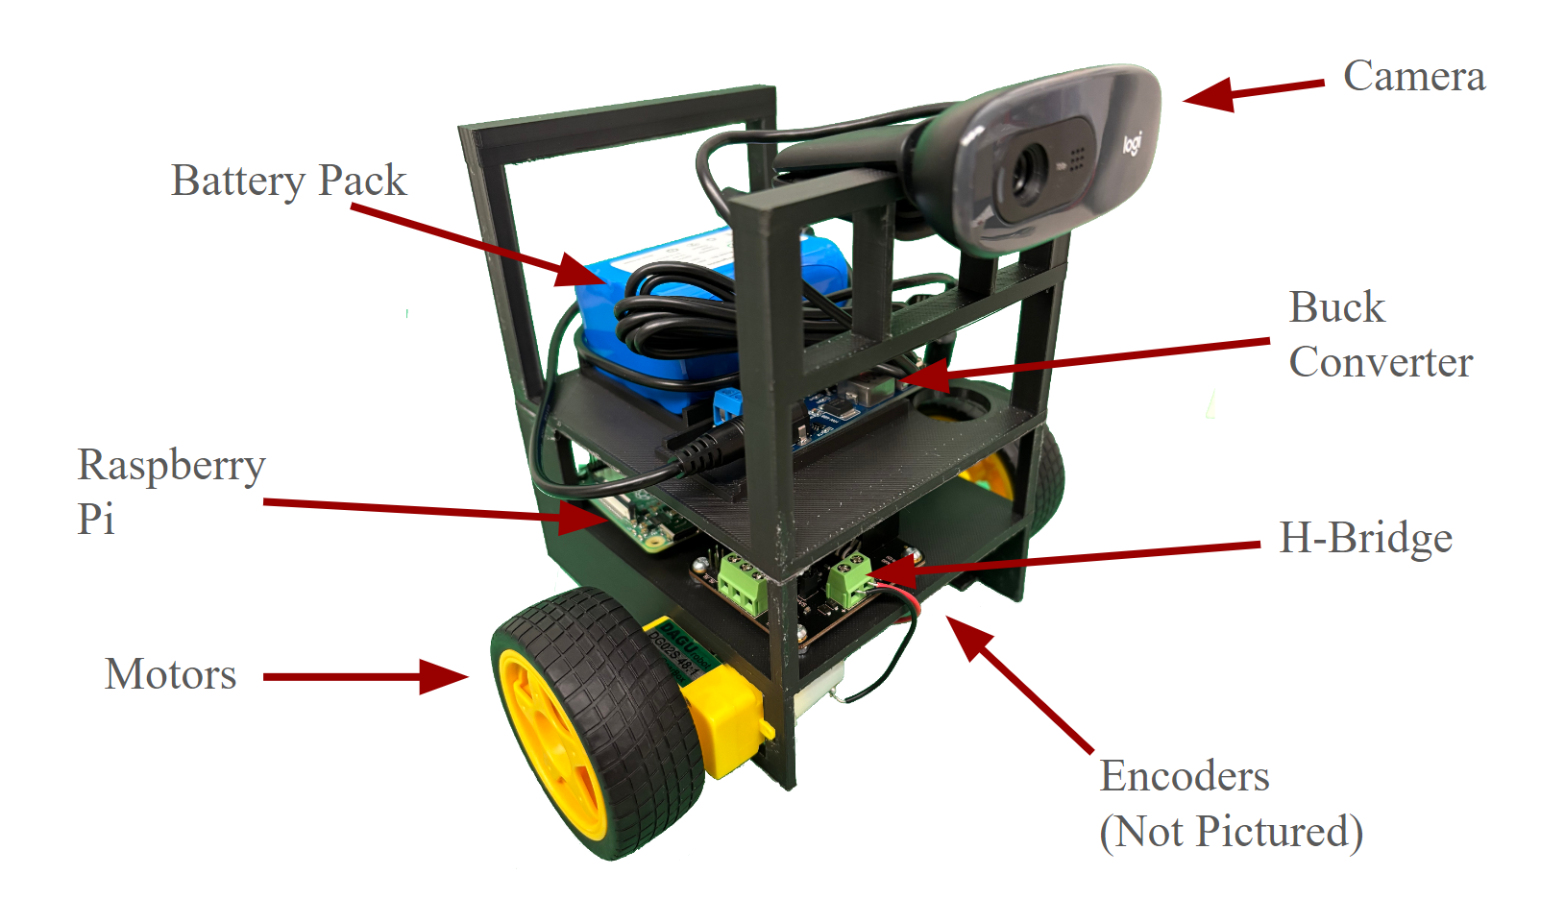

**Figure 11** Final Robot Design, Labeled

### 3.4 Improving the Chassis

We reviewed the chassis model files for the previous group's iteration of the chassis, and were able to see how their design was suited to their needs, as their chassis housed all of the elements they used such as the Raspberry Pi, camera, etc. From there, we modified the chassis for our design. To achieve this, we modified the chassis lengthwise and widthwise, adding approximately 12 millimeters for the new motors and wheels. This gives our robot a larger base increasing its stability.

During the first design, we made changes including expanding the chassis lengthwise and widthwise by about 12 millimeters, adding a dedicated battery spot, moving the BeagleBone Blue and Raspberry Pi around to remove cable clutter, and creating slots for the new motors and their encoders.

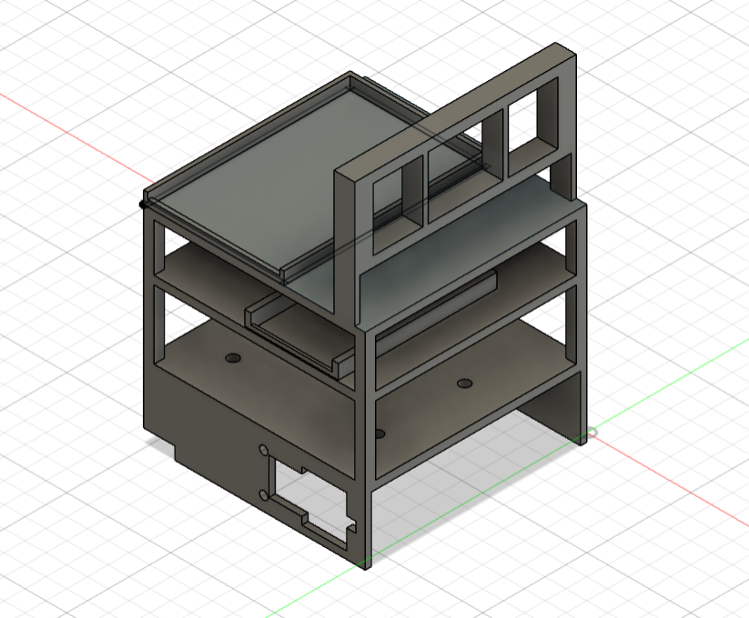

**Figure 12** CAD File of the current chassis version

During the first iteration of the chassis, the motors that we selected were a different fit than the previous motors that prior groups used, and needed approximately 12 millimeters more clearance on the inside of the chassis. The alignment of the motors and encoders were fixed with modification in the second iteration, but ran into issues with the balance of the components due to the back wheel being too low. On the third iteration of the chassis, the motors were able to fit into place and fasten to the robot without modification, but the back wheel was still too low, and the battery would not fit into the designated spot. The fourth, and most recent iteration, fixed these issues; the battery was able to be slotted into its holder, the motors and their wheels were moved forward, and the back wheel was moved up more to balance the robot, along with a new holder for the Raspberry Pi on the top shelf of the chassis. Iterations one, two, and four of the first design are shown below in Figure 13.

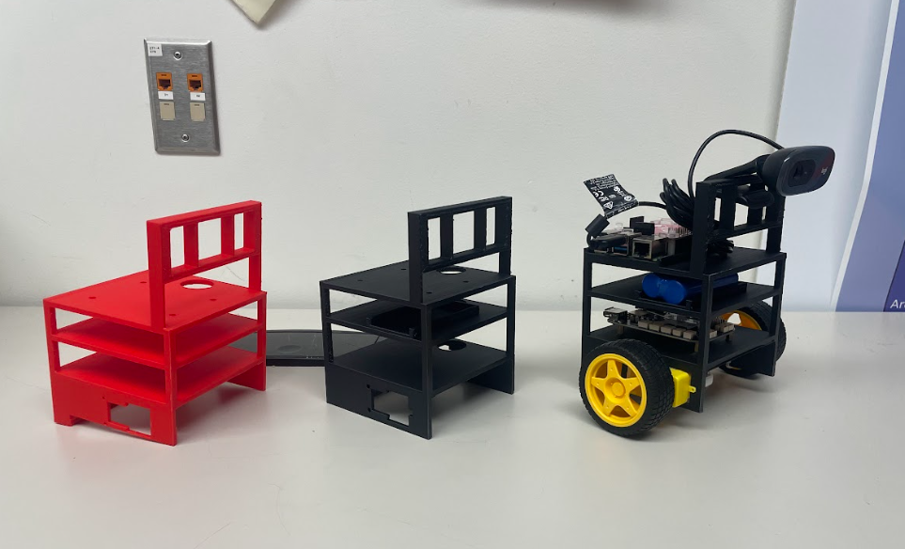

**Figure 13** Three iterations of the first design in order of their development

During the creation of the third and most recent design, we made modifications to the chassis to help with balancing the robot by adding approximately 20 millimeters to the depth of the chassis. Before this change, when the robot would drive forward and stop, the robot would be top heavy and tip over. After making this change, we made other changes to the design of the robot; adding new slots for the battery, the voltage converter, the Raspberry Pi, and the H-bridge.

Due to the removal of the Arduino, and the change of the battery to power the robot, we decided to remove the middle shelf that previously held the battery and move the Raspberry Pi to a dedicated spot on the bottom shelf. This allowed the wires that connected the Raspberry Pi to the H-bridge and encoders to be significantly shorter, allowing us to have cleaner wiring. The top shelf, which previously held the Raspberry Pi, was dedicated to the new battery and the new voltage converter.

After we modified the chassis to the current iteration, we discovered that approximately twenty-five percent of the filament required to print each chassis was going to be used for support that was removed and discarded at the end of each print. To remedy this, we decided to explore rotating the chassis so that it would print on its side. Printing the chassis on its side decreased the amount of filament required to print. The side print method had issues with the support filament being difficult to remove, which led us to our final method of printing. To combat the amount of filament required, and to make the supports easy to remove, we decided to slice the print in half, and print the top and bottom pieces separately. This method removed the supports between the top and bottom layers, and made the remaining supports easy to remove. Figure 14 shows the slices of the final chassis.

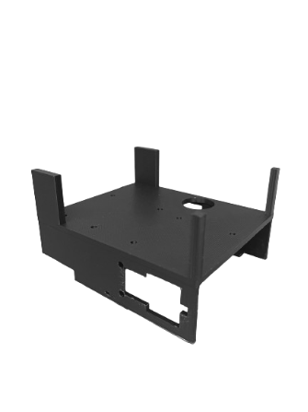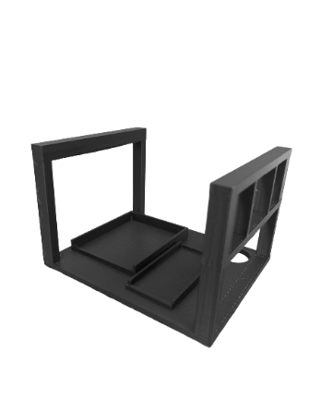

**Figure 14** Final slice of chassis, bottom (left) and top (right)

### 3.5 Pose Detection using Computer Vision

In Boids, each boid determines its movement based on its neighbors. Therefore to implement Boids using robots, we need robots to be aware of their neighbors. As discussed in the background section, previous groups developed systems to solve this problem. In this section, we will discuss the two systems used by previous groups, how effective they were, and the system we created to solve this problem.

The first group created the swarm robotics project using AprilTags to detect the positions of other robots. AprilTags are a visual fiducial system – similar to QR codes – developed by researchers at the University of Michigan.[9] The system was designed for the purpose of robotics research and includes a robust detection system written in C that can detect tags in varied lighting conditions and at angles. Figure 15 shows the design of two types of AprilTags.

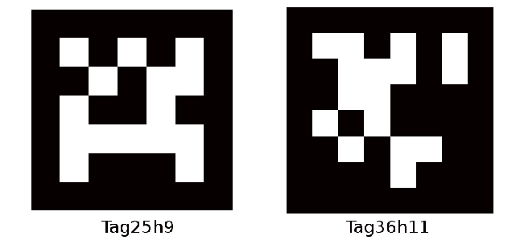

**Figure 15** Example of AprilTags

The 2021-2022 team used AprilTags by mounting them on the robots. An overhead camera running the AprilTag detection system was used to detect the robots’ positions via the mounted AprilTag. As part of their research, the group characterized the performance of the AprilTag system which we will briefly present here. The first test the group ran characterized how the system performs in relation to a tag’s distance from the camera. Figure 16 shows the result of their experiment. The group found that tags were detected consistently at distances of 1.5 meters or less, but as distance increased past 1.5 meters, the detection rate quickly dropped off. The group also tested how many tags could be detected in one frame. Figure 17 shows the relationship between tags and detection rate. They found that the AprilTag system could consistently detect up to 75 tags with minimal loss in the detection rate. The speed of the system decreased with each additional tag, though, which is shown in Figure 18. Since the tags were mounted on robots, the group realized that the AprilTags aren’t guaranteed to be facing the camera directly. Because of this, they also tested how the angle of a tag impacted detection. When testing tags placed at a 45 degree angle relative to the camera, the group found that the detection rate was still quite good. The result is shown in Figure 19. Similar to their previous test, the speed of the system, shown in Figure 20, followed a decreasing trend as more tags were in frame.

Overall, the group found that the AprilTag system was computationally expensive and performed poorly on slower systems. Despite this, the Raspberry PI they used for tag detection was powerful enough to run the system at an acceptable speed.

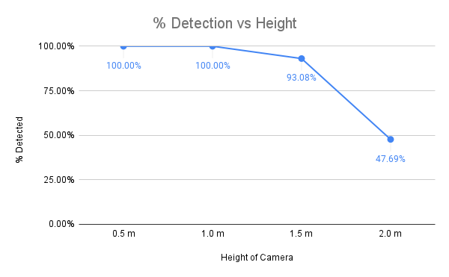

**Figure 16** Graph of detection percentage vs AprilTag distance to camera

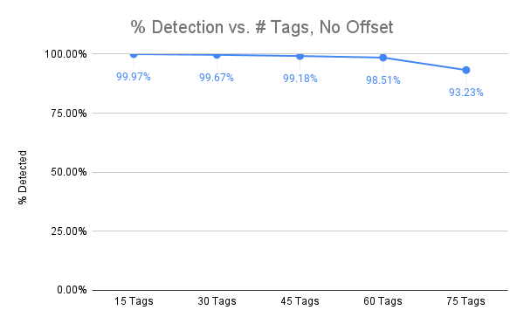

**Figure 17** Graph of detection percentage vs the number of AprilTags in the image

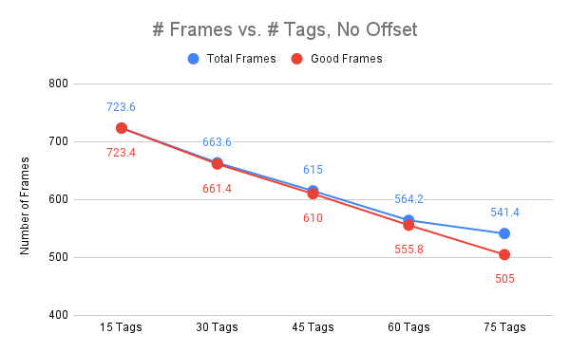

**Figure 18** Graph of frames processed per minute vs number of AprilTags. Good frames represent frames in which all tags were detected.

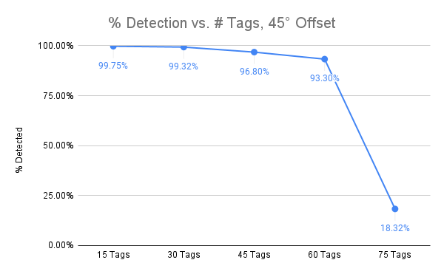

**Figure 19** Graph of detection percentage vs the number of AprilTags in the image. Tags were angled at 45 degrees relative to the camera.

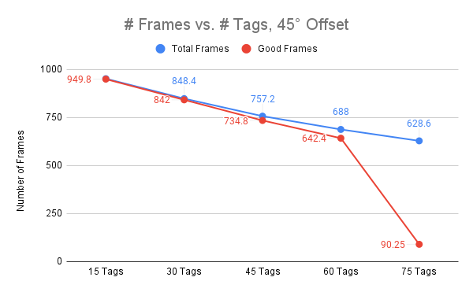

**Figure 20** Graph of frames processed per minute vs number of AprilTags. Tags were angled at 45 degrees relative to the camera.

When the 2022-2023 senior design team picked up the project, they tried to run the AprilTag detection system on a BeagleBone Blue. Unfortunately, they discovered that the hardware was not powerful enough to run the system at an acceptable speed. Because of this, the group used the OpenCV library to create their own tag detection system as a replacement for AprilTags. The system they built used colored squares as tags. We will refer to this system as the colored square detector since the previous group didn’t give it a name.

After investigation of their code, we found OpenCV was all that was required to get their system running. We originally planned to do tests on the system to characterize its performance, but we quickly realized that the system was so unreliable that formally conducting tests would be a waste of our time. The detection of tags was inconsistent and highly influenced by lighting effects and other environmental factors. In addition, false detections were a common occurrence because there was no mechanism for differentiating a tag from a random square in the environment. Figure 21 shows an example of how lighting effects influence detection. Figure 22 shows an example of a false detection.

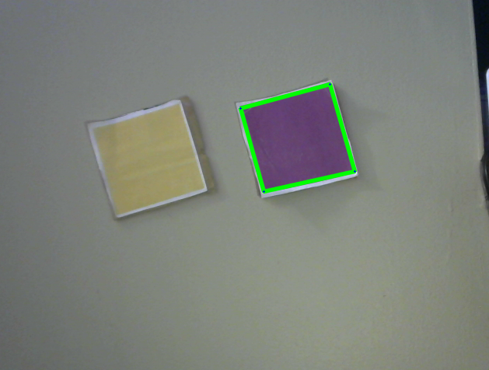 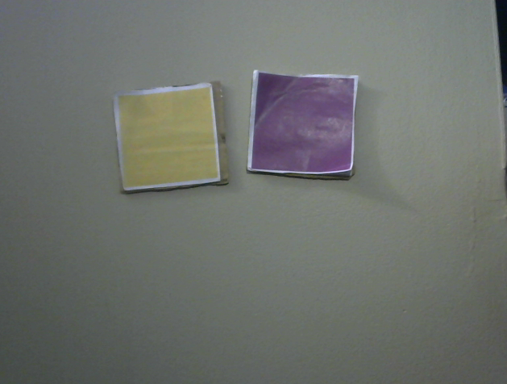

**Figure 21** Demonstration of how lighting effects prevent square detection. In the left image, the purple tag is detected, but in the right image, specular reflections cause the tag to be missed. The system fails to detect the yellow tag in both frames.

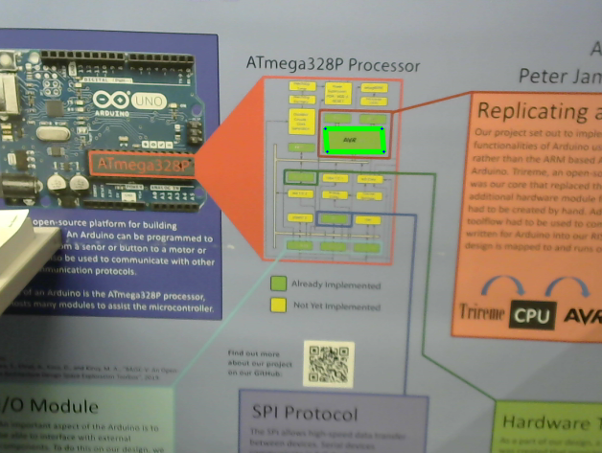

**Figure 22** Example of a false detection. The square on this poster is detected as a tag which is undesirable.

After reviewing the work from the previous groups on the tag detection systems, we constructed a table to compare how the system performs in different categories. Table 1 below shows the result of our analysis where green represents acceptable, red is unacceptable, and gray means untested and unknown.

|  | AprilTags | Colored Square Detector |
| --- | --- | --- |
| Detection rate at various angles and sizes |  |  |
| Resilient to shadows and reflections |  |  |
| No false positives |  |  |
| Performance |  |  |

**Table 1** Analysis of AprilTags and the Colored Square Detector.

After our analysis, we found that neither system performed to our satisfaction. While AprilTags are highly reliable in a variety of environments, the computational requirements of the system exceed what our hardware can provide, and the Colored Square Detector did not adequately solve the problem it was designed for.

For the reasons mentioned above, we decided to develop our own vision system using OpenCV to locate the position of objects in the environment. Our initial idea was to create a cube with an LED at each corner which is shown in Figure 23. The camera would first detect the LEDs using a low exposure image, and then the high intensity areas of the image would be filtered to leave only the LEDs in the image. This process is shown in Figure 24. From this point, the detected LEDs would be used to find the cube’s corners and determine its position. To determine the orientation, the color of the cube’s faces would be used.

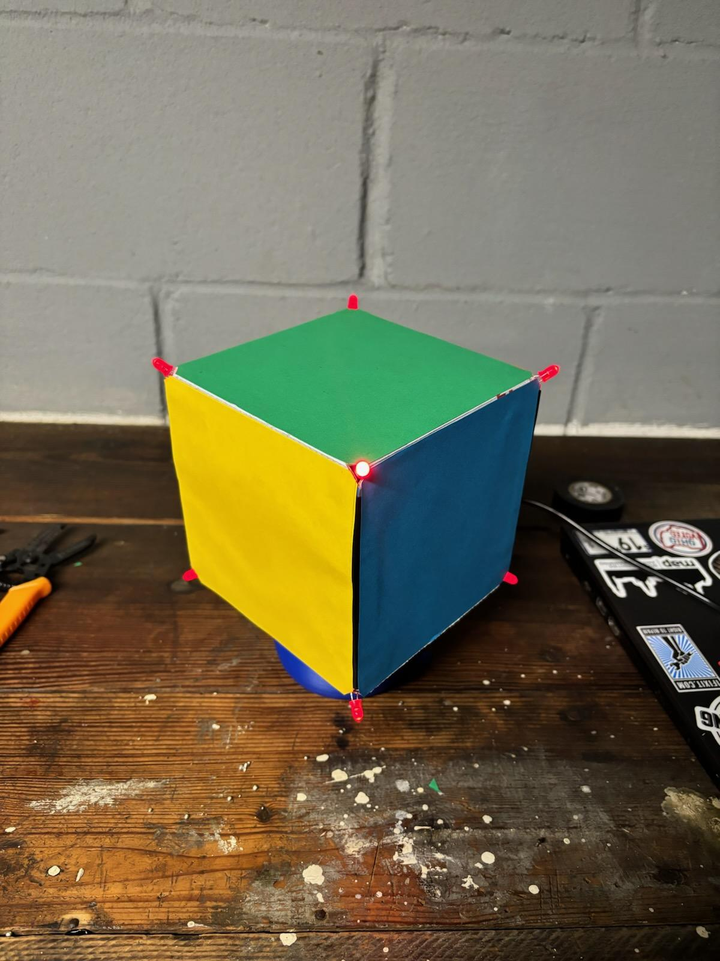

**Figure 23** The first design for the vision system.

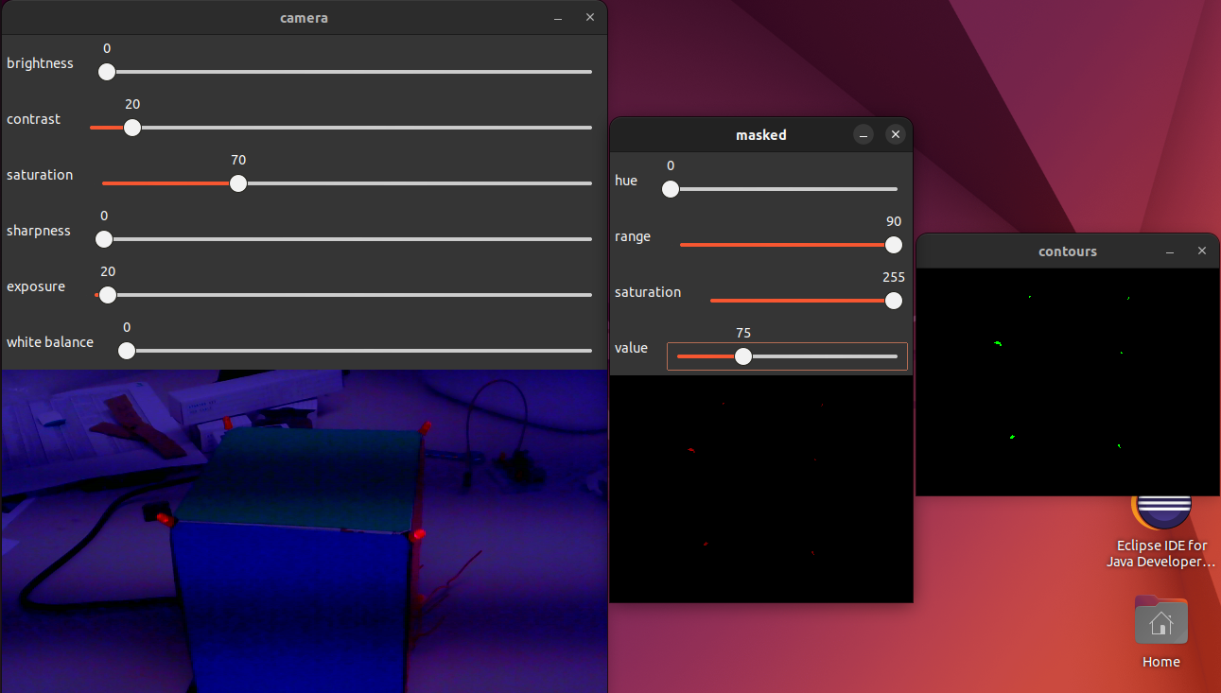 

**Figure 24** Detection of LED corners using a low exposure shot, where the left image shows a low exposure shot from the camera, and the right image shows the result of filtering.

Unfortunately, there are two problems with this approach. The first problem is horizontal banding in the low exposure images which can be seen on the left image of Figure 24. This proved to be problematic since the bands cause a non-negligible difference in the intensity of the image. If an LED is located in a dark band, it will often go undetected. It is difficult to compensate for this issue because the band moves over time.

The second issue we encountered is due to the radiation pattern of the LEDs. When viewed directly by the camera, the LEDs are easy to detect, but when viewed at an angle, the intensity of the light transmitted by the LEDs diminishes. This made the LEDs hard to detect at angles greater than 60 degrees. This concept is illustrated in Figure 25. Using an orthographic projection, we calculated the angle of the LEDs relative to the camera for three cases: corner, edge, and face. The calculation results are shown in Figure 26. In the corner and edge cases, only one or two of the LEDs are at angles less than 60 degrees which is not enough to reliably detect the cube.

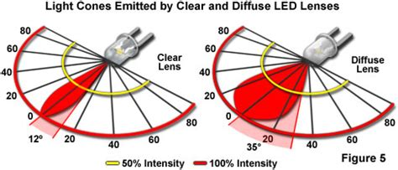

**Figure 25** An example radiation pattern of an LED.

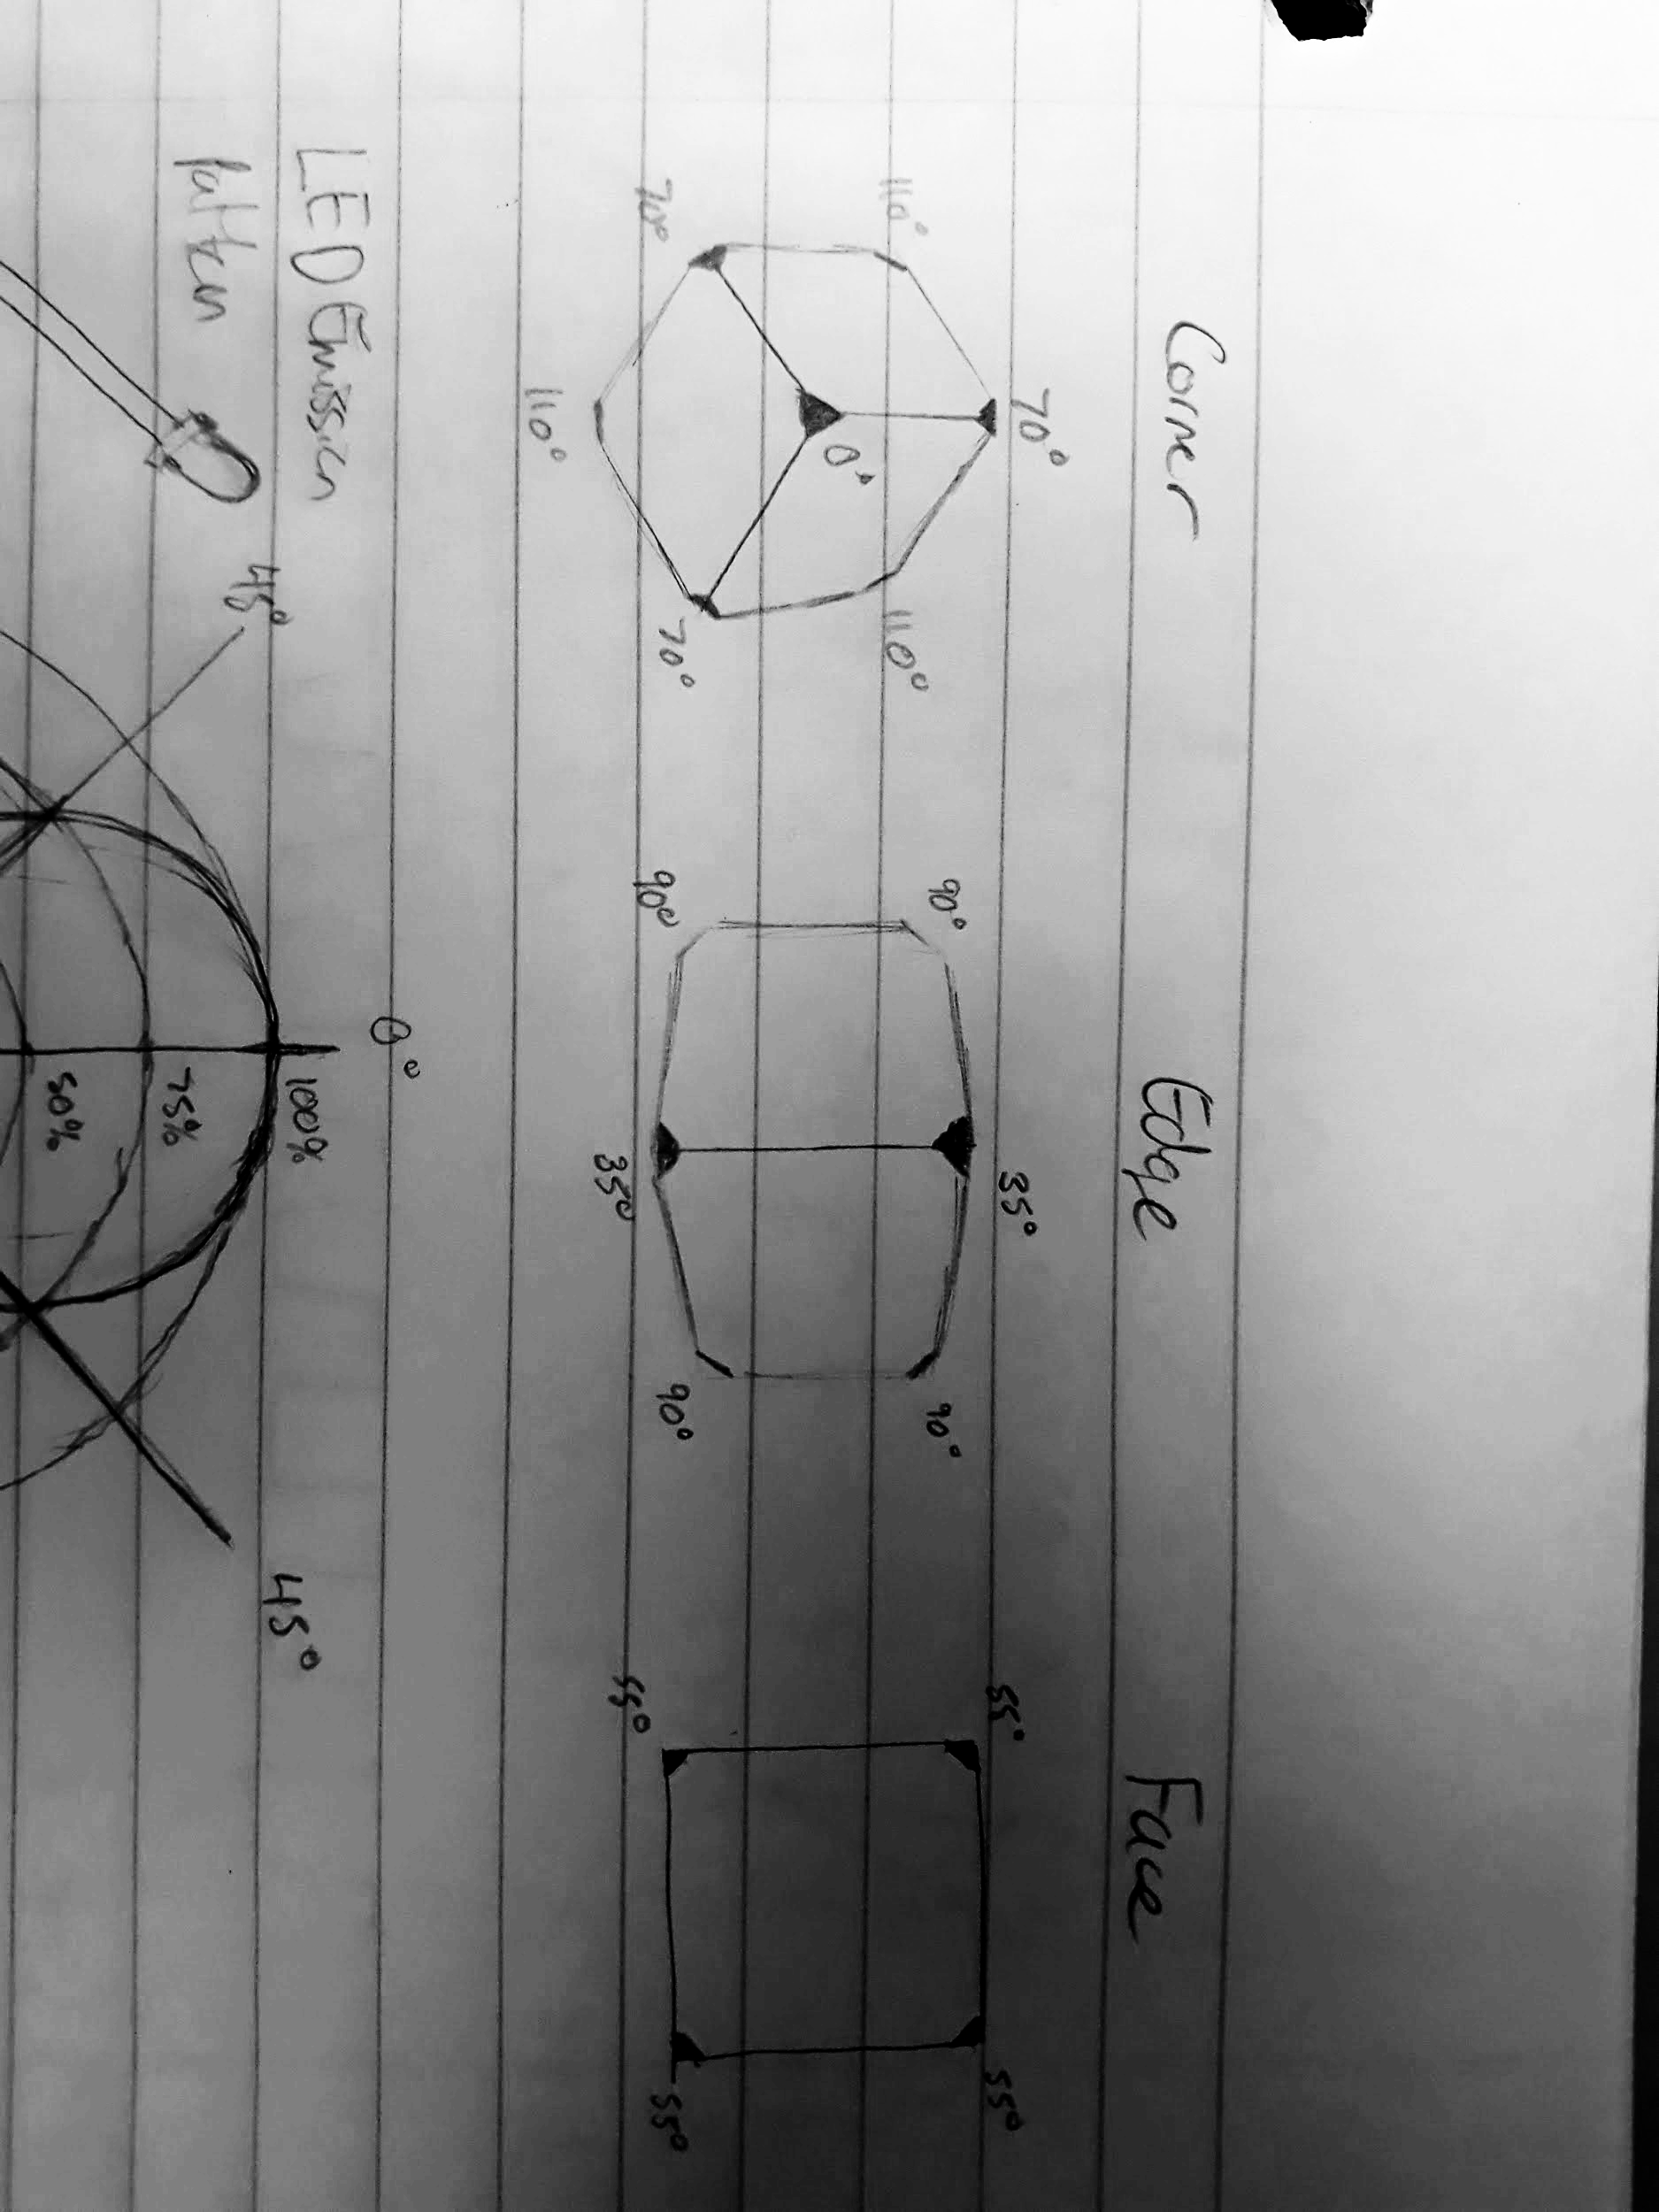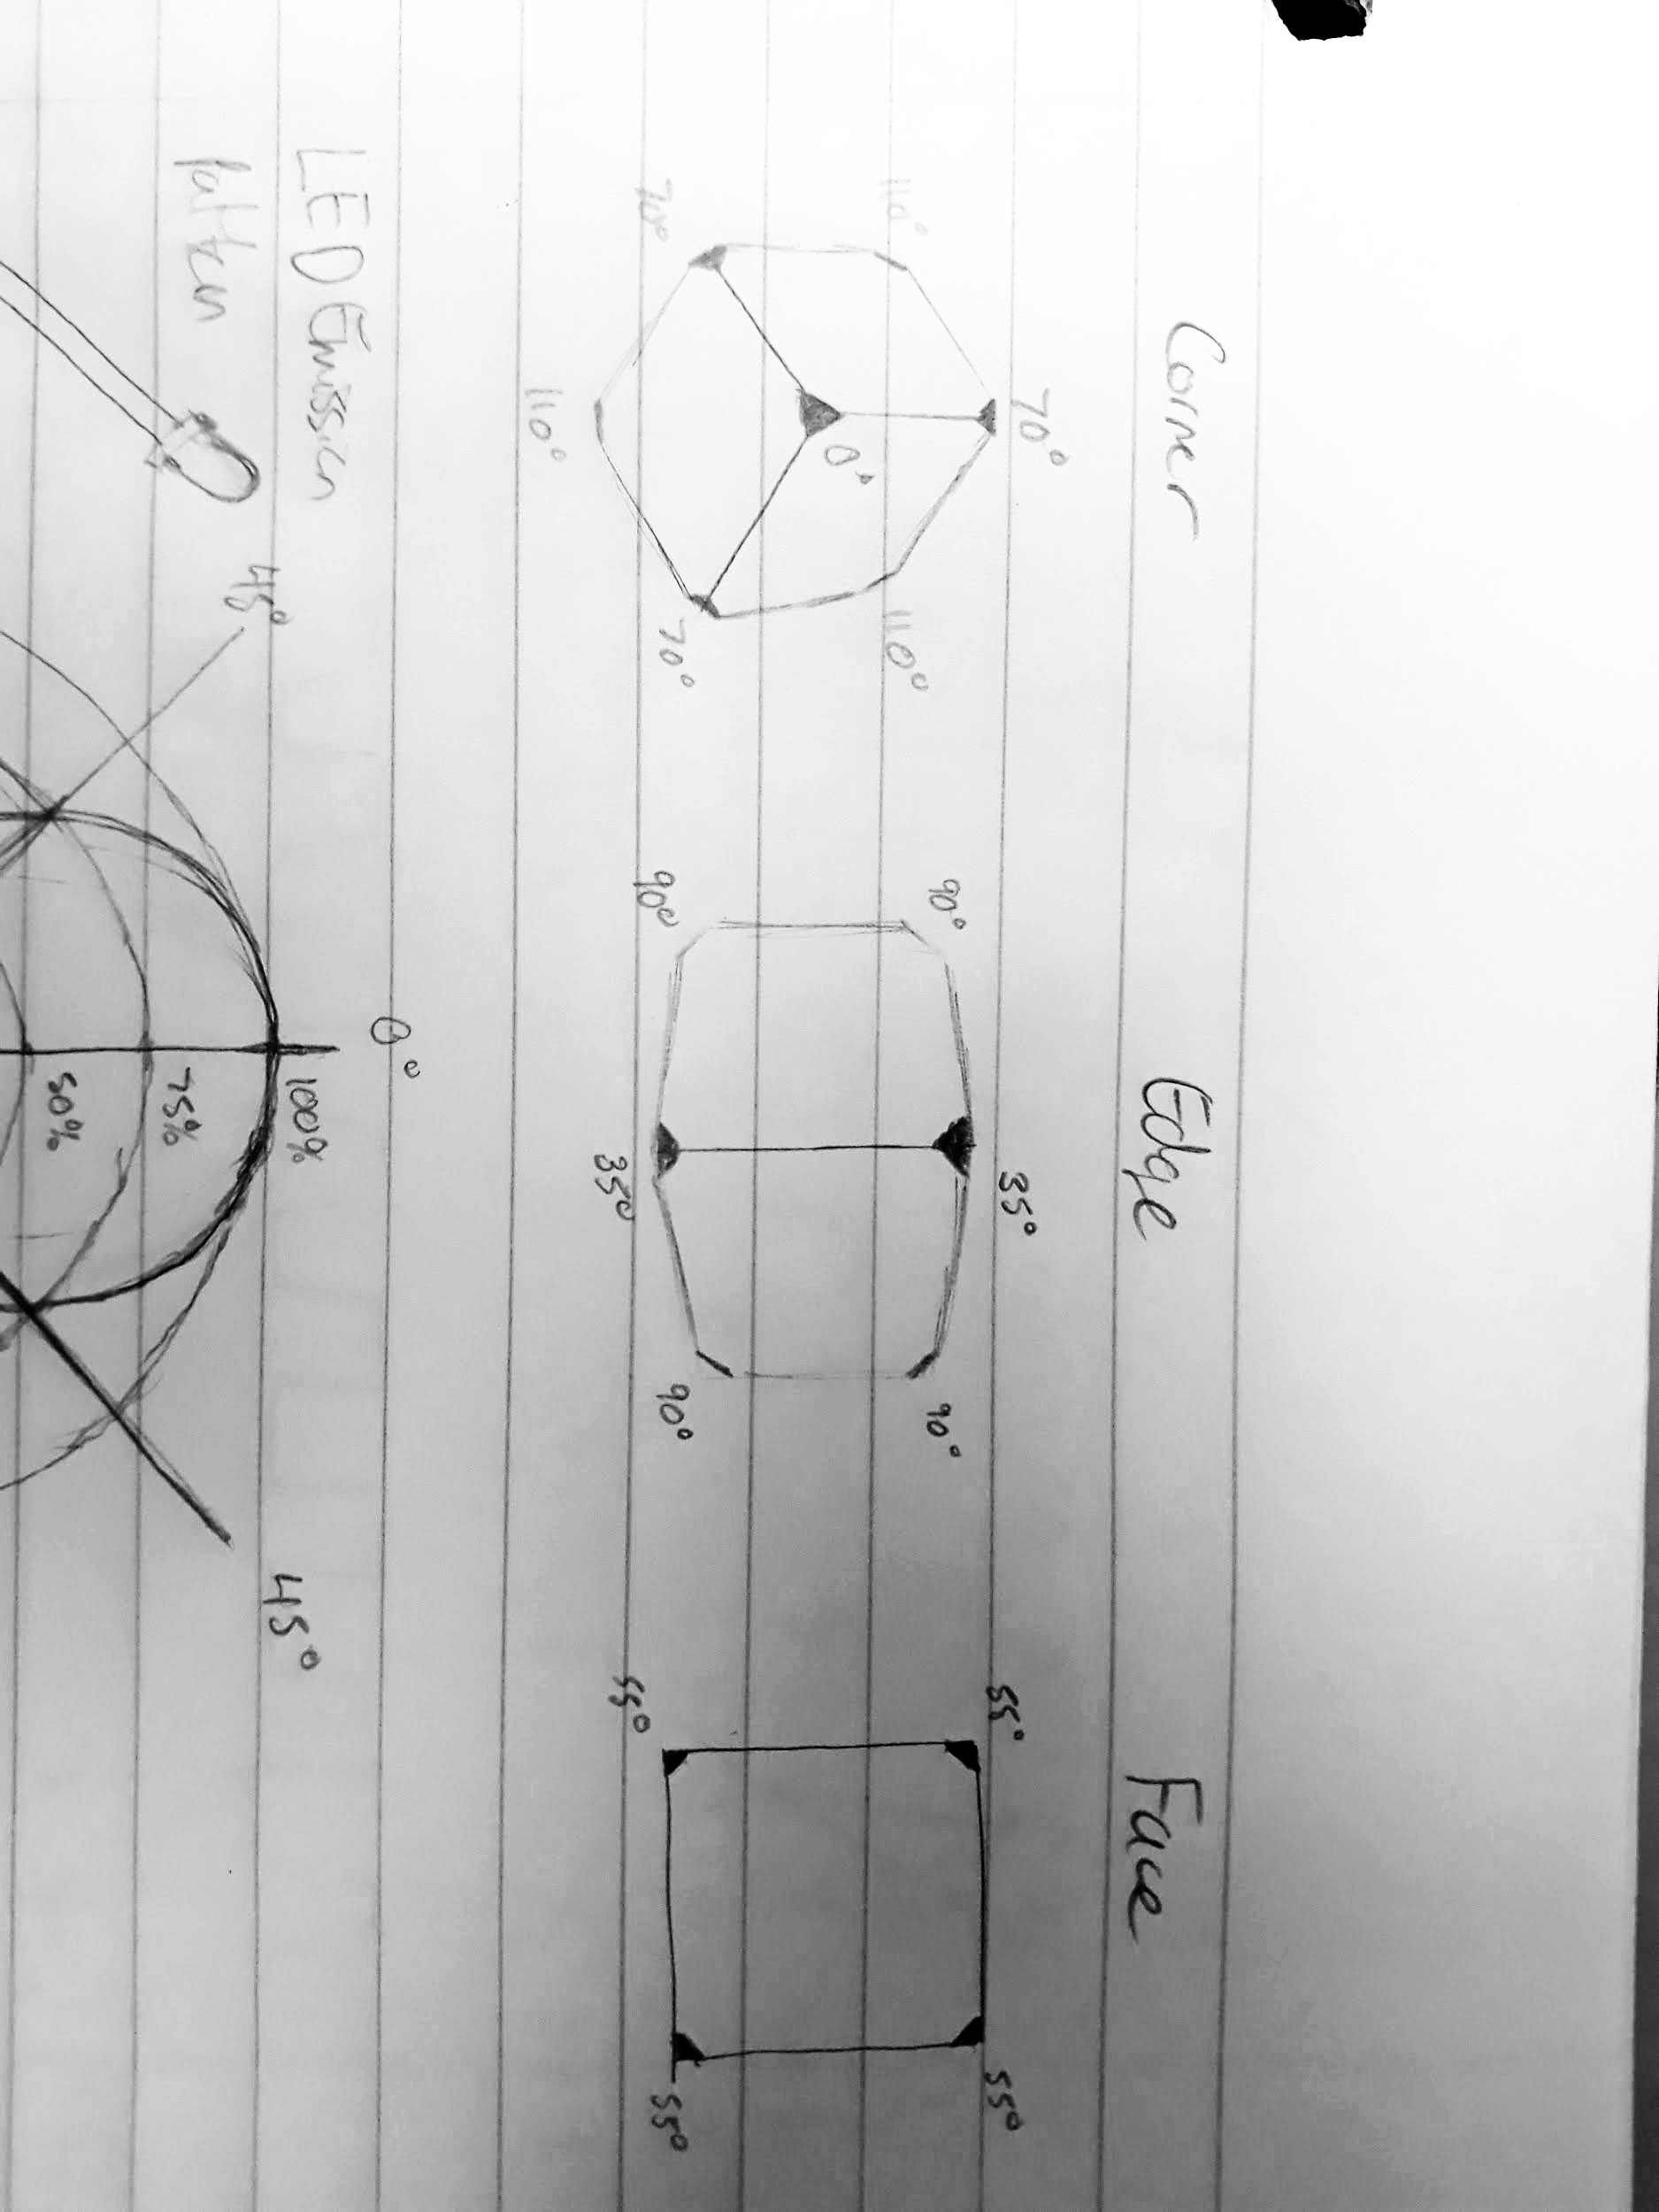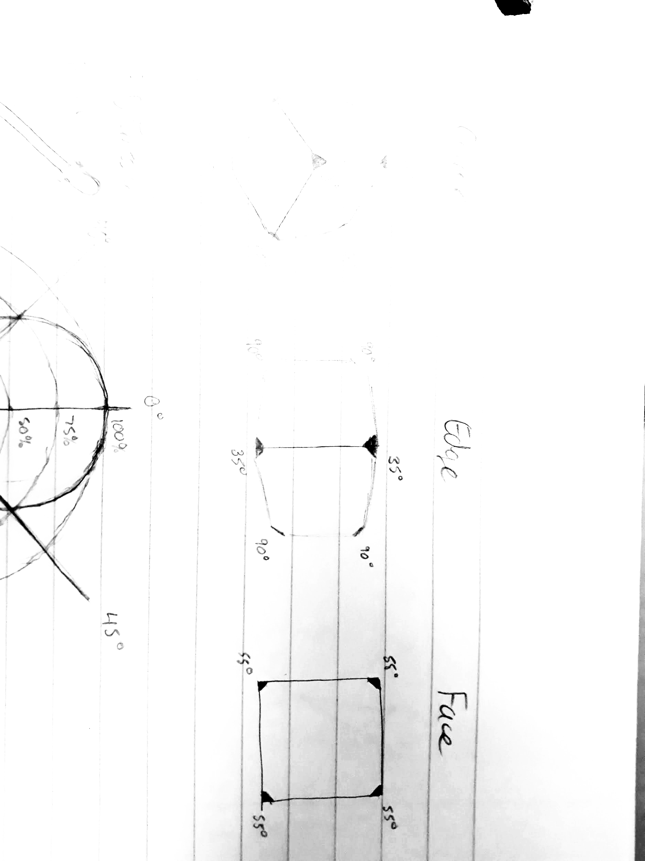

**Figure 26** Calculated LED angles for the three cases.

Due to the issues with the LED corner design, we realized that we needed to take a different approach. After some thinking, we concluded that the biggest problem with our initial approach was this: the LEDs were too small of a target for detection. With this lesson learned, we reevaluated our options.

Initially, we thought the Colored Square Detector was not a viable solution to our problem, but our need for a larger detection target caused us to take a second look at the system. From our analysis of the Colored Square Detector, we found the two issues with the system were its susceptibility to lighting effects and false positives, so we set out to remediate these problems.

The issues with lighting were caused by the material of the tag since it was paper with ink printed onto it. This made the tag very reflective, so we experimented with changing the tag’s material to colored construction paper which was less reflective. This change mitigated the problem and made the tag far more resilient to lighting conditions.

The problem of false detections required a more complex solution. The main cause of false detection was the lack of features that differentiate the targets from their surrounding environment. To solve this problem, we added triangular corners to the square tag to create a regular octagon with four corners. The color of the octagon was made complementary to the corners' color to ensure the shapes could be differentiated from each other. To prevent interference from the background, a black border was added to the tags. We created tags in six different varieties so they could be used for multiple purposes. The final tag design is shown in Figure 27. This design is dubbed as ‘OctoTag’ because of the octagon that defines the tag. Figure 28 shows the six variations of OctoTags constructed for the project.



**Figure 27** The final tag design.

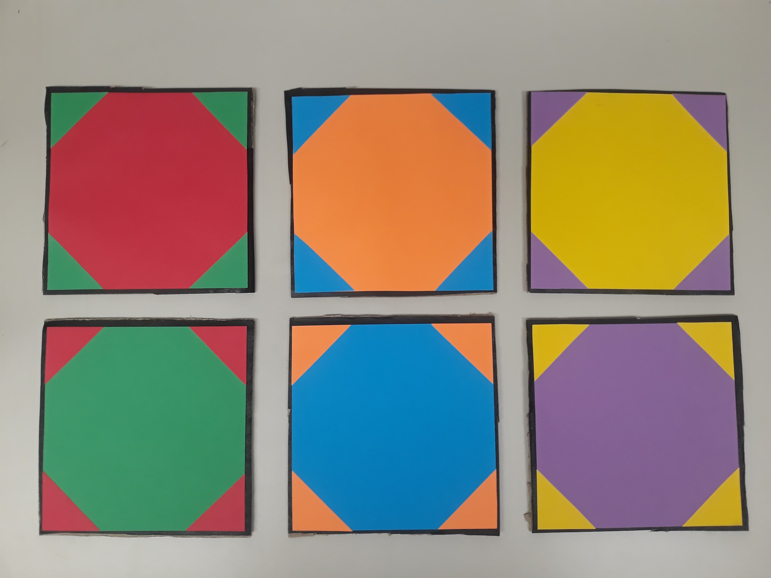

**Figure 28** Six constructed tags with different color variations.

To detect the OctoTags, we created a detector using OpenCV. The detector first filters the colors of interest from an image. After that, contours are detected in the filtered image. A triangle and an ellipse are fit to each contour, and the area of the contour is divided by the area of the fitted triangle and ellipse to determine the ‘triangularity’ and ‘ellipseness’ of each contour. The value for each range from zero to one. From there, the detector marks all contours with an ellipseness above a threshold value as a potential tag. For each potential tag, the detector looks for four triangles at opposing corners. If all four acceptable triangles are found, the shapes are grouped together as a tag. Finally, the pose of the tag is estimated using perspective-n-point (PnP). Figure 29 shows a screenshot of the detector program detecting an OctoTag.

Using the OctoTags, we constructed a mountable target for each robot. This target consisted of four uniquely colored tags arranged in a square shape. Figure 30 shows the target for the robots.

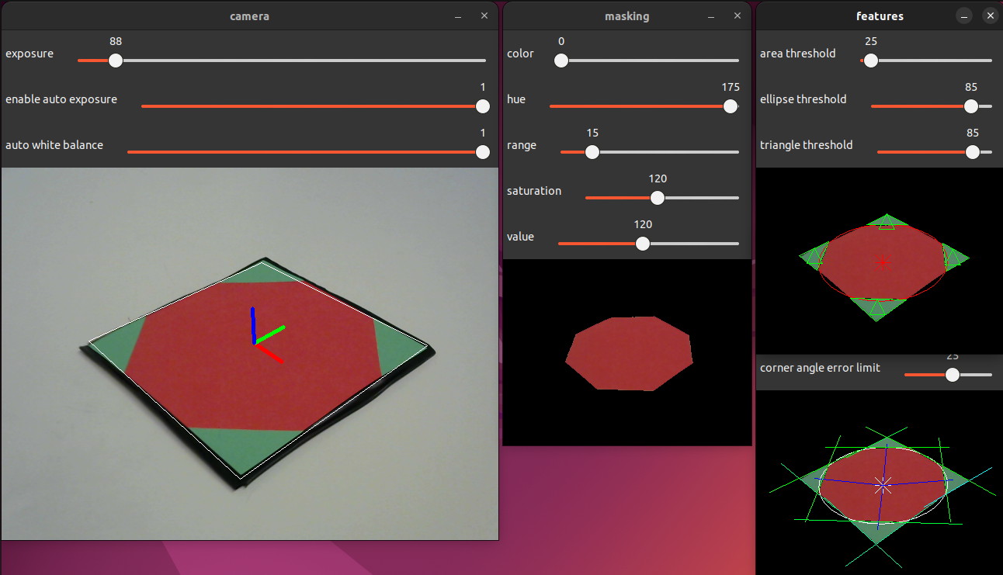

**Figure 29** Screenshot of the OctoTag detector. The frame on the left shows the original image with the tag’s detected pose. The frame in the middle shows the filtering step for the red color. The top right frame shows the fitting of triangles and ellipses to each contour. The bottom right frame shows the four corners being grouped together with the ellipse.

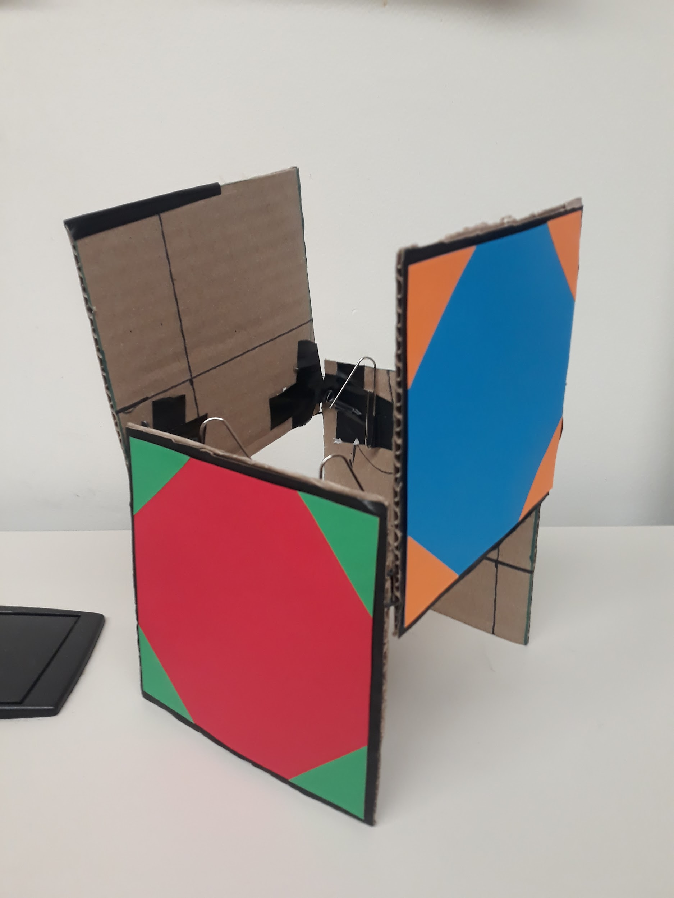

**Figure 30** OctoTag target mounted on each robot.

### 3.6 Implementing Boids using Pose Detection

To be able to implement Boids in real life, there were multiple aspects of Boids that we kept, adding on our own designs in the software and hardware space to attempt to make the algorithm realizable. In the physical world, these boids were put inside four walls to prevent them from running off. These walls were lined with purple and yellow OctoTags to enable the robots to better detect the difference between them and other boids. Additionally, the boids were equipped with OctoTags to be detectable by the other robots.

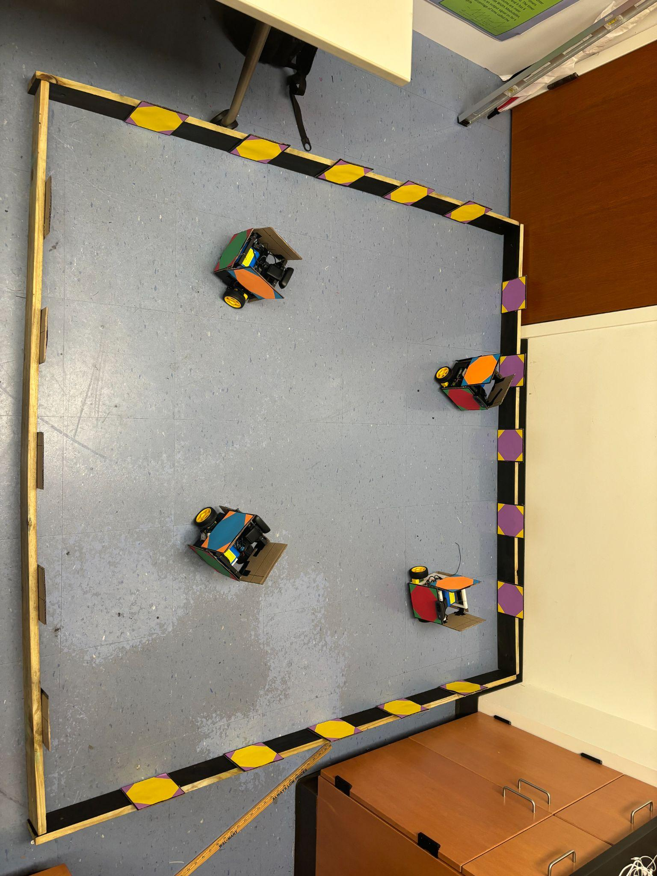

**Figure 31** Boids environment with robots and walls.

In our code, we created structures to be able to group OctoTags together into walls and robots. These wall objects contain information on the distance of the wall from the camera, and the angle of the wall relative to the center axis of the camera. The robot objects contain information about the distance of the observed robot, the angle of the robot relative to the center of the camera, and the heading of the observed robot. These parameters can be observed in Figure 32.

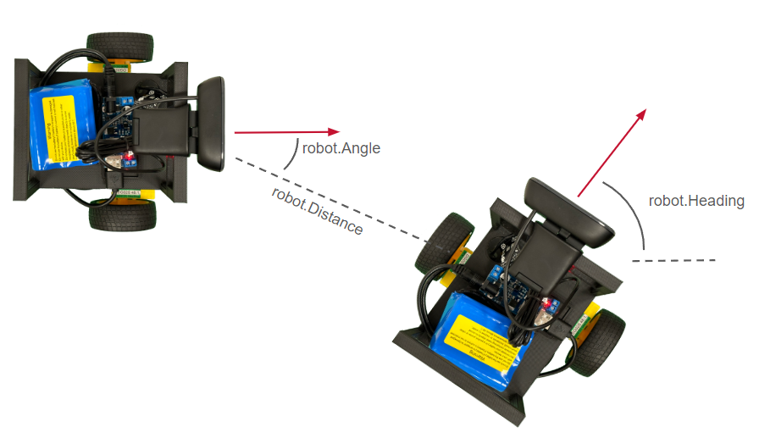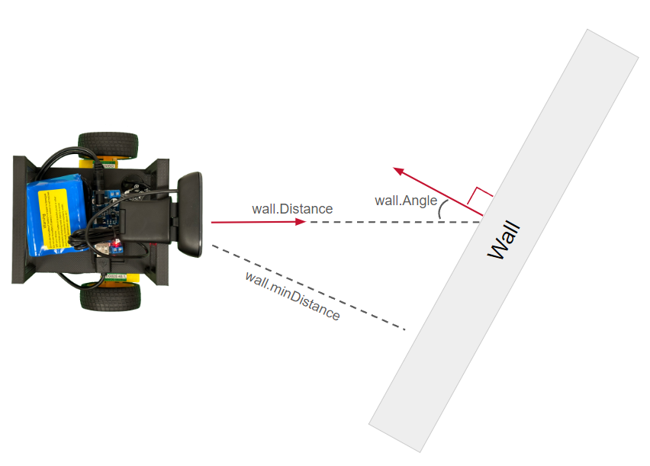

**Figure 32** Visualization of parameters used in boids implementation

To effectively use these robot and wall parameters, we used a state machine model to make decisions of how to drive any given robot. The less complex of the two states used is the stop state. This state works as imagined, where it fully stops the robot. This allows the robot to sense tags without any motion blur, a large contributing factor of accuracy of tag detection. Once out of this state, the robot then uses the tag information available to determine its next decision based on 4 different scenarios. If no tags are detected, the robot spins around, giving it a new angle and a highly increased chance of tag detection. If only walls are detected, the robot calculates if it is too close to any of these walls. If it is, then it turns to avoid said wall. If not, then it drives forward. If only robots are detected, then the principles of separation and cohesion are applied to attempt to replicate flocking behavior. Alignment was not able to be applied in this scenario, as that requires the velocities of the neighboring robots, which we were unable to obtain in the scope of this project. The last of the four possible scenarios is where both walls and robots are detected. If this is the case, the robot avoids any walls that are deemed to be too close, and if possible applies separation and cohesion.

In practice, we found this system to be able to somewhat display the Boids algorithm. The robots were able to sense walls and one another, basing their decisions on this information. However, due to the limited field of view of the camera and fluctuating lighting conditions affecting tag detection, the robots struggled to demonstrate behavior that appeared to show themselves “flocking” together. Movement of the robot also causes blurring in the camera’s images which causes tag detections to be missed.

## 4 Final Results

We are mostly satisfied with the current design of our chassis. We have started printing it in pieces to make the supports easier to remove and assembly of the robots less of a hassle. It also has reorganized the components in a satisfactory manner, properly holds the LiPo battery used to power our Raspberry Pi, accommodates the extra space needed for our new motors and encoders, and more adequately stores our camera. The chassis tipping over with a sudden stop was a problem last semester we fixed through simple modifications to the chassis. The placement of the screw holes could be improved however to prevent portions of wires sticking out from the chassis, inhibiting proper placement of our OctoTags.

Through our investigation of the two systems previously used to detect the position of neighboring robots, we found that neither system was adequate for our purposes. While the AprilTags system was highly effective at detecting tags, we determined that our hardware was not adequate for running the system. We also found that the colored square detector from last year's group was unusable. The OctoTag system we created proved to be effective for our purposes.

As for the movement of the robots, we found it to be somewhat satisfactory for our needs as the robots do make movements based on tag detections, however the improvement of the sensing capabilities and the creation of a more complex algorithm that is able to detect the velocity of neighboring robots could lead to a much better representation of boids algorithm.

## 5 Future Work

There are multiple aspects of this project that could be improved by future groups. The first of these could be improving the visual sensing system. The accuracy of OctoTag detection, given it is color based, can be sensitive to lighting changes. Throughout the use of this project we used manual sliders to calibrate the camera to adequately distinguish these colors, however a future group could create code to be able to calibrate the detector to automatically adapt to different lighting situations. Additionally, it could prove useful to experiment with different OctoTag sizes, as OctoTags sometimes would be larger than the camera's image if too close to the camera. Another possible addition would be to give the robots a wider field of view. In simulations, boids make their decisions based on 360° of vision. Given our robots had 60° of this vision, adding additional sensors such as cameras, lidar, or other distance sensors could prove very useful in accomplishing boids as intended. Finally, as smaller modifications, acquiring higher quality motors, encoders, and cameras could improve the control of the robots’ movement. From here, expanding the number of boids would be imperative to recreate boids more accurately to how it is often displayed in simulations.

## 6 Engineering Standards and Practices

Throughout our time as students at Miami University and working on this project, we have learned a great deal about the professional and ethical standards engineers should hold themselves to. Specifically, this project taught us the importance of communication. Many of the difficult problems that caused delays were due to poor documentation and parts that were hard to integrate together. Had updated and comprehensive documentation been available for the work we were building upon, we feel we would have been able to do more. As engineers, it is important to effectively document how systems work so others can understand the work and how to safely use it.

Regarding the impact our project has in different contexts, such as public health, safety, and welfare, we believe our project has the potential to be impactful on public safety. If fully realized and applied in a search and rescue or land mapping sense, it could be possible that this system could assist these efforts in finding a missing person or avoiding dangerous areas of land. These areas of focus strongly emphasize the professional and ethical responsibilities we have as engineers. Given the possible environmental impact of land surveying, it is imperative to create robust systems that produce accurate results.

Additionally, we have explored how to act in a way that keeps the general welfare of the public first and to speak in a way that is honest and responsible to improve the engineering profession. We have also developed an understanding of the need for engaging in life-long learning, as this not only improves us as engineers, but the safety, efficiency, and efficacy of all the projects we interact with. Finally, we have enlarged our understanding of the world as a whole. This has helped us understand the impact of our work on the globe and society as a whole.

## 7 Conclusions

We feel as if we made good improvements from the last group even though our outcomes are not perfect. We managed to reduce the hardware of each robot, lowering, cost, power consumption and complexity, mainly by eliminating a second microcontroller. On top of this we managed to make the chassis easy to work with, improving the ease of replication. Also we improved the detection system moving from colored squares to our own OctoTag system. This system still has flaws being heavily affected by lighting conditions and movement. Also the limited field of view of the robots often leads to missed detections. This could possibly be improved with a different camera, more reliable motors, and an added calibration method to help with the changes caused by lighting changes.

1. <https://en.wikipedia.org/wiki/Swarm_behaviour>
2. <http://www.scholarpedia.org/article/Swarm_robotics>
3. <https://www.beagleboard.org/boards/beaglebone-blue>
4. <https://github.com/Cole-Heng/Swarm_Robots>
5. <https://github.com/ptyn7600/Swarm-Robot-USS-2022>
6. <https://github.com/vannescc/USS2023_Swarm_Robotics/tree/main>
7. <https://dl.acm.org/doi/pdf/10.1145/37401.37406>
8. <https://en.wikipedia.org/wiki/Boids>
9. <https://april.eecs.umich.edu/software/apriltag>